# F-Score vs number of clusters for Clustering on Ground truth

1. EM + similarity matrix formed using FastText trained on homeautomation Wikipedia corpora

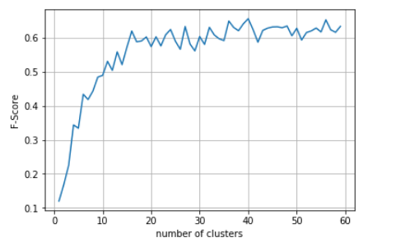

1. EM + similarity matrix formed using FastText pretrained on wikinews

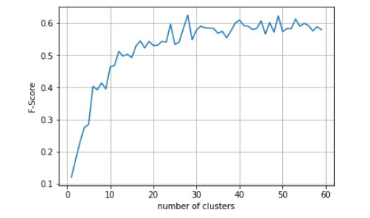

1. KM + similarity matrix formed using FastText trained on homeautomation Wikipedia corpora

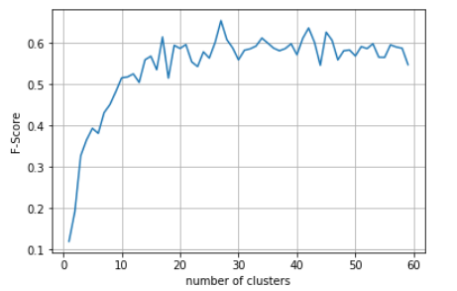

1. KM + similarity matrix formed using FastText pretrained on wikinews

